DESIGN AND IMPLEMENTATION OF STUDENT RESULT COMPILATION SYSTEM
(A CASE STUDY OF GOMBE STATE POLYTECHNIC BAJOGA)

BY

GROUP 13

S/N | NAME | REG.NUMBER
1 | MUHAMMAD KABIR USMAN | GSPB/ND/CS/B/19/0432
2 | HAUWA AHMAD | GSPB/ND/CS/A/19/0275
3 | ADAMU USMAN | GSPB/ND/CS/B/19/0381
4 | ALI HAMZA | GSPB/ND/CS/A/19/0394
5 | SANDRA STANLEY | GSPB/ND/CS/B/19/0510

A PROJECT SUBMITTED TO THE DEPARTMENT OF COMPUTER SCIENCE, SCHOOL OF SCIENCE AN TECHNOLOGY, GOMBE STATE POLYTECHNIC BAJOGA IN PARTIAL FULFILMENT OF THE REQUIREMENT FOR THE AWARD OF NATIONAL DIPLOMA (ND) IN COMPUTER SCIENCE

MARCH, 2022

DECLARATION
We hereby declared that this work is the product of our research effort, undertaken under the supervision of Mr. Ismail Abdulkarim Adamu and has not been presented and will not be presented elsewhere for the award of ND certificate. All sources have been dully acknowledged.

S/N NAMES SIGNATURE DATE
- MUHAMMAD KABIR USMAN _________________ ________________
- HAUWA AHMAD _________________ ________________
- ADAMU USMAN _________________ ________________
- ALI HAMZA _________________ ________________
- SANDARA STANLEY _________________ ________________

CERTIFICATION

This is to certify that the project title “Student Performance Evaluation System” was carried out under the supervision of:

_______________________________________ ________________________
Name and Signature Date
(Project Supervisor)

_______________________________________ ________________________
Name and Signature Date
(Head of Department)

_______________________________________ ________________________
Name and Signature Date
(External Examiner)

ACKNOWLEDGEMENT

All praises and gratitude are solely due to Allah (SWT) who create, sustain, guides and bless us with sufficient intellectual capability to complete this work. First and foremost, we would like to thank our Supervisor Mr. Ismail Abdulkarim Adamu for his guidance and constructive criticism throughout this work. We thank him for painstakingly reading the manuscript, making corrections, checking software and suggestions for improvement where necessary. This work would not have been successful without his support and encouragement.
For special care, concern and untiring assistance, we thank immeasurably our parents, brothers and sisters for supports and encouragement toward the realization of this study.
Special thanks go to our Lecturers: Mal. Ibrahim Hassan (HOD Computer Science), Mal. Ahmed Haruna Dokoro (Class Adviser), Mal. Mustapha Umar (Exam Officer), Mr. Joshua Umaru (Special Technician), Malama Amina (Clerical Officer) and the other staff Academic and Non-Academic from various Department/Units for making valuable comments and contribution, assistance with ideas and materials, encouragement and special concern.
Also, we wish to appreciate our friends and colleagues during our stay in Gombe State Polytechnic, Bajoga for their prayers. Once more a big thanks to you all and May the Almighty Allah give us the chance to be together.

DEDICATION
We dedicated this study to God Almighty for His guidance, protection, love and care over of our life to ensure our graduation. So also, to our parents for their effort, guidance, encouragement and tolerance which contributed profoundly to our personal and intellectual growth and to what we are today. May ALLAH (SWA) reward you richly, Ameen.

ABSTRACT
Performance evaluation of students in institution is a necessity and this is done based on the Grading system adopted by a school. Computation of Grade point average is done manually and this is time consuming and tedious.
This project views the present system of computing Result and attempts to convert the process from manual to computerized one in order to reduce time spent in computing student’s especially in the final year. Microsoft Visual BASIC programming language was used because of its powerful features to implement the system.

TABLE OF CONTENTS
DECLARATION ii
CERTIFICATION iii
ACKNOWLEDGEMENT iv
DEDICATION v
ABSTRACT vi
CHAPTER ONE 1
1.0 INTRODUCTION 1
1.1 BACKGROUND OF THE STUDY 1
1.2 STATEMENT OF PROBLEMS 1
1.3 AIM AND OBJECTIVES 2
1.4 SIGNIFICANCE OF THESTUDY 2
1.5 SCOPE OF THE STUDY 2
1.6 LIMITATION OF THE STUDY 2
1.7 DEFINATION OF TERMS 2
CHAPTER TWO 4
2.0 LITERATURE REVIEW 4
2.1 INTRODUCTION 4
2.2 WEB DESIGN 5
2.2.1WEB DESIGN TOOLS 6
2.3 CHOOSING THE SOFTWARE 7
2.3.1 ADOBE DREAMWEAVER 8
2.5.2 MICROSOFT EXPRESSION WEB 8
2.5.3 COFFEE CUP VISUAL SITE DESIGNER 9
2.5.4 SERIF WEB PLUS 9
2.5.5 WEBEASY PROFESSIONAL 9
2.5.6 NETOBJECTS FUSION 10
2.5.7 NAMO WEBEDITOR 10
2.6.8 EVRSOFT FIRST PAGE 10
2.5.9 HTML-KIT TOOLS 10
CHAPTER THREE 12
3.0 METHODOLOGY 12
3.1 INTRODUCTION 12
3.2 PRELIMINARY INVESTIGATION 12
3.3 PROPOSED SYSTEM 12
3.4 ANALYSIS OF THE PROPOSED SYSTEM 12
3.5 SYSTEM DESIGN 13
3.5.1 PROPOSED SYSTEM ARCHITECTURE 13
3.5.2 SYSTEM DESIGN METHODOLOGY 14
3.5.3 DATAFLOW DIAGRAM 18
3.6 PROGRAM MODULE SPECIFICATION 19
3.6.1 OUTPUT/INPUT SPECIFICATION 19
3.6.2 OUTPUT SCREENS: 19
3.8 FILE/DATABASE SPECIFICATION 20
3.9 OVERVIEW OF THE PROPOSED SYSTEMS BLOCK DIAGRAM 21
CHAPTER FOUR 23
4.0 IMPLEMENTATION AND TESTING 23
4.1 INTRODUCTION 23
4.2 SYSTEM IMPLEMENTATION 23
4.3 SYSTEM TESTING 24
4.4 SYSTEM CHANGE OVER 23
4.5 SYSTEM REVIEW MAINTENANCE 24
4.6 DOCUMENTATION 24
4.3.1 LOGIN FORM 24
4.3.2 ADMIN DASHBOARD 25
4.3.4 COURSE LIST 27
CHAPTER FIVE 29
SUMMARY, RECOMMENDATION AND CONCLUSION 29
5.1 SUMMARY 29
5.2 CONCLUSION 29
5.3 RECOMMENDATION 29
REFERENCE 31
APPENDIX A 32
APPENDIX B 35

LIST OF FIGURES
Figure 3.1: Proposed System’s Architecture 14
Figure 3.2: Class diagram 14
Figure 3.3: Component Diagram 15
Figure 3.4: E-R diagram 16
Figure 3.5: Sequence diagram 17
Figure 3.6: Activity diagram 17
Figure 3.7: Use case diagram 18
Figure 3.8 Dataflow diagram of the system 19
Figure 3.9: Block Diagram of the Proposed System 22
Figure 4.3.2: Admin login form 25
Figure 4.3.3: Admin Dashboard 26
4.3.3 ADD STUDENT FORM 26
Figure 4.3.4: Student Registration form 27
Figure 4.3.5: Course List 28

CHAPTER ONE

1.0 INTRODUCTION

1.1 BACKGROUND OF THE STUDY
Evaluation is the systematic determination of merit, worth and significance of something or someone. Evaluation often is used to characterize and examine subjects of interest in a wide range of human enterprise including the Arts, business, Computer Science, criminal justice, foundation and non-profit organizations, government and other human services.
Performance Evaluation is a necessity for organizations, institutions and even individuals due to the fact that it helps them to know how they are faring and to know if there is any need for improvement. This research work is going to focus on performance evaluation of students. In schools’ students are evaluated and their result is compared based on the Grading system adopted by a particular school. Some schools adopt the 3.5-point Grading system while others operate on the 4-point Grading system for evaluating student performance and computing their Grade Point Average. However, most schools use the conventional (manual) system for computing the students. There have been numerous problems associated with the conventional system of computation. However in the project we determine to come up with automated system for evaluating student of computer science, Gombe State polytechnic Bajoga.

1.2 STATEMENT OF PROBLEMS
The following are the problems encountered with the use of conventional systems:
Manual computation of Grade point average the work involved in the calculation is tedious, especially, when handling a large class. A lot of time is exhausted and wasted in the process of computing while ensuring accuracy.

1.3 AIM AND OBJECTIVES
The aim of this study is to develop an automated student performance evaluation system that will be able to eliminate the problems associated with the conventional system for evaluating and computing grade point average of students. The objectives of the projects are:
- To Design a prototype system for evaluating student performance using Visual Basic programming language.
- To Compute student’s GPA faster and accurately
- To Compute the GPA at various levels
- To Compute the cumulative GPA (CGPA)
- To State the class of Honors’ a student falls into.
6. Enable students to be able to compute their GPA easily

1.4 SIGNIFICANCE OF THESTUDY
The importance of this study is to be able to evaluate student’s performance so as to save the student, school or Faculty officer from the stress of computing student performance manually which waste a lot of time during the process of computing student result.

1.5 SCOPE OF THE STUDY
This study centers on the computation of GPA for students of the Department of Computer Science of Gombe State Polytechnic Bajoga.

1.6 LIMITATION OF THE STUDY
This project is limited to evaluating the performance of students of computer science department, Gombe State Polytechnic, Bajoga,

1.7 DEFINATION OF TERMS
- Prototype: It is the first or original model from which others are copied
- Evaluation: It involves assessing the strengths and weakness of programs, polices, personnel products and organizations to improve their effectiveness.
- Student: A person engaged in study, one who is devoted to learning; a learner, a pupil, a scholar, especially one who attends a school or who seeks knowledge from professional teacher or from books; as the students of an academy, a college or a university like a medical student, research student etc.
- Grade point average: The average obtained by dividing the total number of grade points earned by the total number of credits attempt.
- Performance: It is the act of performing; the carrying into execution or action, achievement, accomplishment, representation by action, as the performance of an undertaking of a duty.
- Grading: It is evaluation of performance by assigning a grade or score.

CHAPTER TWO

LITERATURE REVIEW

2.1 INTRODUCTION
A student Performance evaluation system is a work that will be able to eliminate the problems associated with the conventional system for evaluating and computing grade point average of students. (Abraham 2007 Boud 1991) defines self-performance as “the involvement of students in identifying standards and/or criteria to apply to their work, and making judgments about the extent to which they have met these criteria and standards: Boud (1995) highlights two main aspects of performance : the first is setting the standards of the levels of achievement expected and the second is evaluating the value of achievement in the light of those standards. By getting involved with both these aspects of performance, students set goals for their learning and start learning for themselves (Harahan & Isaacs, 2001). Thus, the benefits of self-performance can be summarized as follows:
A) Self-performance can provide motivation for further engagement in learning and can also enhance the learners’ responsibility and independence as they take control of their learning (Spiller, 2012).
B) self-performance gives a chance to learners to shift from the view of satisfying their teachers and to focus on a better quality of learning for themselves (Boud, 1995).
Murphy and Tenenberg (2005) at an American University carried out a performance analysis which involved 61 students. The researchers explored the students’ perspectives on the level of their knowledge in data structures. They argue that self-knowledge, or in psychology terms calibration of knowledge, is critical because it has a vital role in metacognitive skills and especially in self-regulation. To measure students’ knowledge, they employed quizzes with multiple-choice questions referring to data structures.
Additionally, the students completed questionnaires that evaluated their calibration ability, an estimation of how well they performed on the quiz. Their findings indicate that students’ estimates about themselves correlated with how they performed in the quiz, although the calibration accuracy of weaker students was less than that of the stronger ones. This needs further discussions about the role that this type of performance could have in computing courses; true reflection and calibration can help students recognise their learning needs while, imprecise calibration, like over-estimation, may lead to failure (Sheldrake et al., 2014). Murphy and Tenenberg (2005) highlight the important role of calibration in computing courses.

2.2 WEB DESIGN
Web design is the “skill of creating presentations of content (usually hypertext or hypermedia) that is delivered to an end-user through the World Wide Web, by way of a Web browser or other Web-enabled software like Internet television clients, micro blogging clients and readers” (Thorn, 2003).
The intent of web design is to create a web site—a collection of electronic documents and applications that reside on a web server/servers and present content and interactive features/interfaces to the end user in form of Web pages once requested. Such elements as text, bit-mapped images (GIFs, JPEGs) and forms can be placed on the page using HTML/XHTML/XML tags. Displaying more complex media (vector graphics, animations, videos, sounds) requires plug-ins such as Adobe Flash, QuickTime, Java run-time environment, etc. Plug-ins are also embedded into web page by using HTML/XHTML tags.(Thorn, 2003)
Improvements in browsers' compliance with W3C standards prompted a widespread acceptance and usage of XHTML/XML in conjunction with Cascading Style Sheets (CSS) to position and manipulate web page elements and objects. Latest standards, and proposals, aim at leading to browsers' ability to deliver a wide variety of content and accessibility options to the client possibly without employing plug-ins.
Typically web pages are classified as static or dynamic: Static pages don’t change content and layout with every request unless a human (web master/programmer) manually updates the page. A simple HTML page is an example of static content.
Dynamic pages adapt their content and/or appearance depending on end-user’s input/interaction or changes in the computing environment (user, time, database modifications, etc). Content can be changed on the client side (end-user's computer) by using client-side scripting languages (JavaScript, JScript, Action script, etc.) to alter elements (DHTML). Dynamic content is often compiled on the server utilizing server-side scripting languages (Perl, PHP, ASP, JSP, ColdFusion, etc.). Both approaches are usually used in complex applications.
With growing specialization in the information technology field there is a strong tendency to draw a clear line between web design and web development.
Web design is a kind of graphic design intended for development and styling of objects of the Internet's information environment to provide them with high-end consumer features and aesthetic qualities. The offered definition separates web design from web programming, emphasizing the functional features of a web site, as well as positioning web design as a kind of graphic design.
The process of designing web pages, web sites, web applications or multimedia for the Web may utilize multiple disciplines, such as animation, authoring, communication design, corporate identity, graphic design, human-computer interaction, information architecture, interaction design, marketing, photography, search engine optimization and typography.

2.2.1WEB DESIGN TOOLS
(i) Markup languages (such as HTML, XHTML and XML)
(ii) Style sheet languages (such as CSS and XSL)
(iii) Client-side scripting (such as JavaScript)
(iv) Server-side scripting (such as PHP and ASP)
(v) Database technologies (such as MySQL and PostgreSQL)
(vi) Multimedia technologies (such as Flash and Silverlight)
Web pages and web sites can be static pages, or can be programmed to be dynamic pages that automatically adapt content or visual appearance depending on a variety of factors, such as input from the end-user, input from the Webmaster or changes in the computing environment (such as the site's associated database having been modified).
With growing specialization within communication design and information technology fields, there is a strong tendency to draw a clear line between web design specifically for web pages and web development for the overall logistics of all web-based services.

2.3 CHOOSING THE SOFTWARE
Web design software may depend on many factors. How advanced needs to be determined, as well as how easy to use. For a professional web designer, a software with all the latest features will be needed. On the other hand, for an inexperienced designer with computers and wish only to create a site featuring pictures of family or a blog, a simpler program would be better suited for your needs.
There are many web design software programs in the market, and new ones are released all the time, as technology advances. For professional designer, You will need to find a design software that supports complex computer programming language. Some may even allow you to code the language you are using directly into the software.
These complex web design programs are necessary for larger sites which require sophisticated common gateway interface (CGI) scripts and other backend commands. More complicated scripts are important in order for the site to read and send forms, online payments, display graphics and videos, and provide other technologically advanced features. When picking out software for professional use, be sure it says on the site or packaging that it is suitable for professional designers.
For novice designer who needs web design software more for personal use than professional, a simple program is probably more suitable. There are many commercial software applications available that allow everyday consumers to create very attractive sites with little or no technical knowledge. Generally, these programs provide a simple layout that can be altered with text, graphics, and colored backgrounds.
2.3.1 ADOBE DREAMWEAVER
Adobe Dreamweaver is the most powerful web design software program in the market today. It is a product of Adobe Systems Incorporation. You may hear many people saying that, It is also a popular website creator and editor or it is a full feature web page design software package. Yes, it is true. It is the top choice for professional web designers and web developers. It provides endless features ranging from standard to advanced functions.

2.5.2 MICROSOFT EXPRESSION WEB
Microsoft Expression Web is a website creator and editor by Microsoft Corporation. It is one of most popular web design software solution on the market today. It provides all the tools you need including HTML, XHTML, CSS, JavaScript, PHP, ASP.NET, ASP.NET AJAX, visual diagnostics and CSS design capability to produce high-quality and standards-based websites. The package includes Expression Web + SuperPreview, Expression Design and Expression Encoder + IIS Smooth Streaming. Expression Design is a professional design tool for creating graphics content that can be used within Expression Web.

2.5.3 COFFEE CUP VISUAL SITE DESIGNER
Coffee Cup Visual Site Designer is one of popular website creator and editor in the market today. It is a product of Coffee Cup Software, Incorporation. The program is designed to help you make web pages with ease and speed, and you can make a web page even if you have no experience or HTML knowledge. The program provides drag and drop interface which you can simply drag and drop images or text on the page. It makes designing process quick and simple, you can adjust image or text until you got what you like. The software comes with 10 web page themes to start you off.

2.5.4 SERIF WEB PLUS
Serif Web Plus is one of popular web design software packages in the market today. It is a website creator and editor developed by Serif Ltd. The program is designed for all types of users whether you are a novice or a seasoned designer, a hobbyist or commercial designer. You can design and create professional websites with no complicated code, programming or design experience required. With drag and drop feature, you can create a website with no need to learn HTML. You can add buttons, fonts, colors, table and other web element by using drag and drop with mouse. The keyboard shortcuts and the on-screen tools are customizable.

2.5.5 WEBEASY PROFESSIONAL
WebEasy Professional is a web design software solution from Avanquest Software. It provides complete solution for web creation. There are two editions of WebEasy Professional, Standard and Platinum Edition. The Platinum edition has higher price and more advanced features such as Advanced E-Commerce Solutions for product, inventory and customer management. The program included 1 year hosting plan or you can use your own if you prefer.

2.5.6 NETOBJECTS FUSION
Net Objects Fusion is a professional web design software program developed by Net Objects Incorporation. It is a paid version which has more advanced features than free edition, Net Objects Fusion Essentials. With new AJAX Integration, the program utilizes the powerful Ajax framework to combine XHTML, CSS, JavaScript, and XML into a seamless drag-and-drop interface. The program allows you to design your website with drag and drop layouts, site management tools, e-commerce tool, rollover images, custom HTML and scripts, upload files with built-in FTP.

2.5.7 NAMO WEBEDITOR
Namo WebEditor is a WYSIWYG editor, web design software solution from SJ NAMO, Inc. This Web authoring application allows you to create, edit, publish and manage your websites. With its easy to use and Microsoft Office interface alike, make you familiar with the program. You can create site quickly using built-in templates and themes to suite your needs. There are various templates including personal, company, education, community, restaurant, hotel, and presentation site. It provides you all standard web design features.

2.6.8 EVRSOFT FIRST PAGE
First Page is a web design software program developed by Evrsoft. The program is designed for professional web development. This WYSIWYG editor provides various useful web design features and support for HTML, XHTML, PHP, ASP, Cold Fusion, JavaScript, CSS, SSI and Perl. But the program has not been updated since 2006.

2.5.9 HTML-KIT TOOLS
HTML-Kit Tools is a web design software program for web designer and developer. It is the new version of HTML-Kit (HTML-Kit is a free HTML editor which you can download and use for free). There are many new major features in HTML-Kit Tools such as intuitive user interface; projects with virtual and remote FTP folders; ability to take HTML-Kit Tools, settings, templates and plug-ins in portable USB devices; new HTML Tidy interface that can highlight suggested code improvements; document structure and functions view for HTML, XHTML, XML, CSS, PHP and more.

CHAPTER THREE

3.0 METHODOLOGY

3.1 INTRODUCTION
This project is aimed at developing a web-based system, which manages the activity of “Student Performance”. This system will manage the performance and maintain a performance list of all student in the particular class database. Allocation of performance will be done by lecturers registered in this system through a list of exams scores in the department database organized by the departmental board.

3.2 PRELIMINARY INVESTIGATION
During the analysis of the manual system, we have found a lot of bugs pertaining the system, which make the system non-efficient and lacked accuracy. Below are the list of the problems of the manual system:
The work involved is tedious especially when handling a large class, a lot of time is exhausted and wasted in the process of computing while ensuring accuracy. Therefore, the newly developed system have the capability of overcoming the listed problems. The system can automatically save the record of each student per semester and also increment on the previous semester in the database. The manual system has no database that use to store the record of the performance of any student. Hence, the system make use of papers to display the performance of a student, when the paper is lost, therefore, the record has been lost as well.

3.3 PROPOSED SYSTEM
To join other standard educational institutions in the world, it became necessary to develop a computerize student performance evaluation system.

3.4 ANALYSIS OF THE PROPOSED SYSTEM
We used qualitative analysis to develop this system which makes it accurate. Qualitative analysis comprises the use of descriptive records which include notes, files, audio. Etc.

3.5 SYSTEM DESIGN
System design is the process of defining elements of a system like modules, architecture, components and their interfaces and data for a system based on the specified requirements.
There are a few features from the existing systems that are employed during the design and implementation phase of the proposed system. These features and functionalities include the user interface, students’ performance prediction, illustration displays and report generation. A good user interface provides a user-friendly interface as it is easy to navigate and not complicated. Meanwhile, the students’ performance prediction is included in the proposed system to make sure the objectives are achieved. Furthermore, the generation of reports in Portable Document Format (PDF) and illustration display such as charts in PDF makes student performance analysis easier. From these features found in proposed system, all the user requirements would be fulfilled.

3.5.1 PROPOSED SYSTEM ARCHITECTURE
A system architecture is the conceptual model that defines the structure, behavior, and more views of a system. Therefore the below diagram shows the structure as well as the behaviors of the system, the behavior of the system is shown in the database where the admin, student, lecturer database are related to student performance analyzer
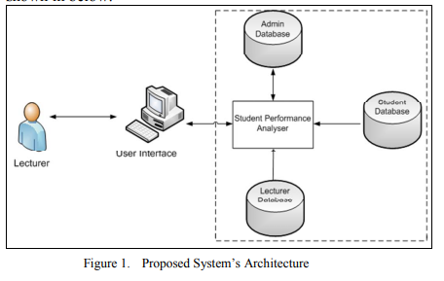

Figure 3.1: Proposed System’s Architecture

3.5.2 SYSTEM DESIGN METHODOLOGY
This is where we represent the data flow, inputs and outputs of the system. Example: ER Diagrams (Entity Relationship Diagrams) as well as the UML diagrams.

3.5.2.1 CLASS DIAGRAM
This diagram describes the structure of a student evaluation system, their attributes, operation (or methods) and the relationships among objects. The main class of the system are student, exam, registrations, results, grade.
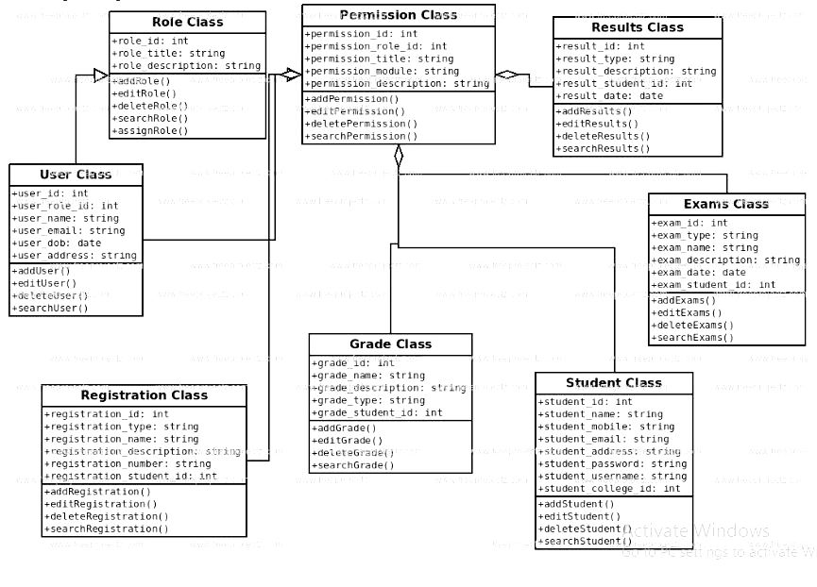

Figure 3.2: Class diagram

3.5.2.2 COMPONENT DIAGRAM
This diagram shows components of the system, provided and required interfaces, ports, and relationship between the grade, student, registration and exams as well as the performance.
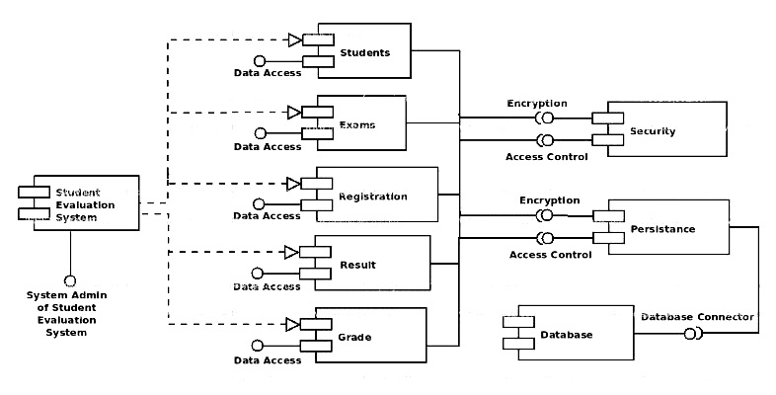

Figure 3.3: Component Diagram
iii. Entity Relationship (E-R) Diagram
This diagram represent the model of student counseling management system entity. The entity-relationship of student counseling management system shows all the visual instrument of database tables and the relationship between the result, students.
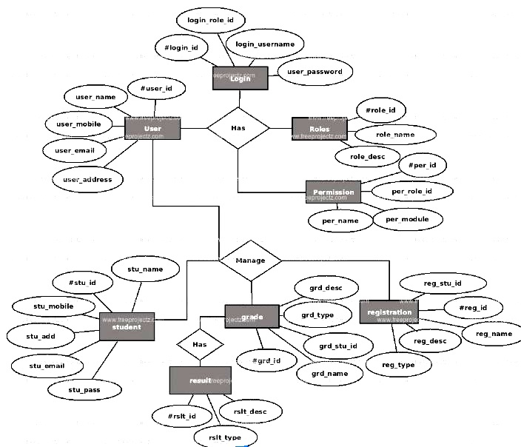

Figure 3.4: E-R diagram

iv. Sequence Diagram
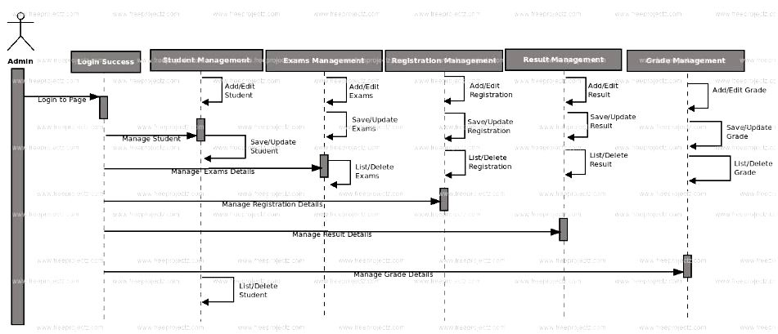

Figure 3.5: Sequence diagram
v. Activity Diagram
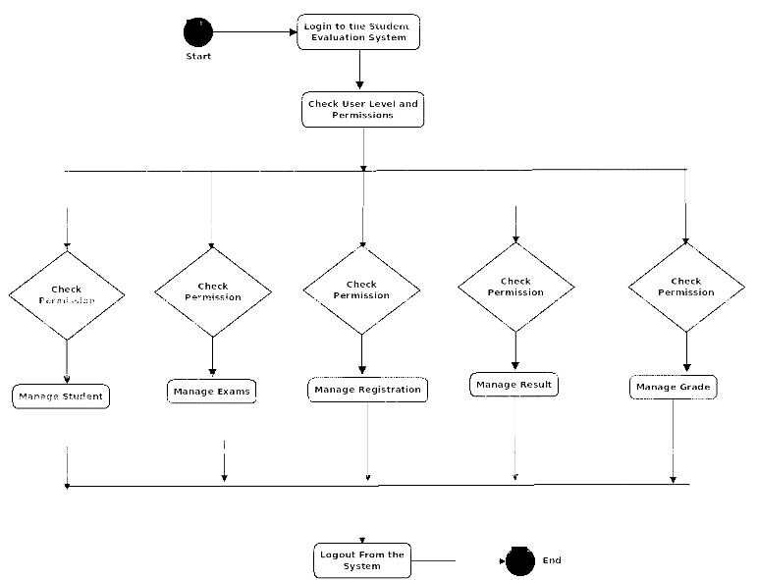

Figure 3.6: Activity diagram

vi. Use case Diagram
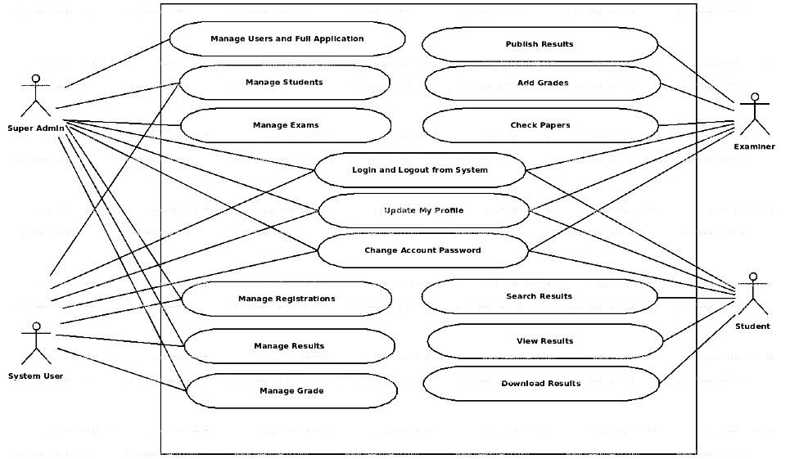

Figure 3.7: Use case diagram

3.5.3 DATAFLOW DIAGRAM
Student evaluation system dataflow diagram often used as a preliminary step to create an overview of the student without going into great detail which can later be elaborated. It normally consists of overall application dataflow and process of the student. It contains all of the user flow and their entities such as all the flow of student, exams, registration, result grade.
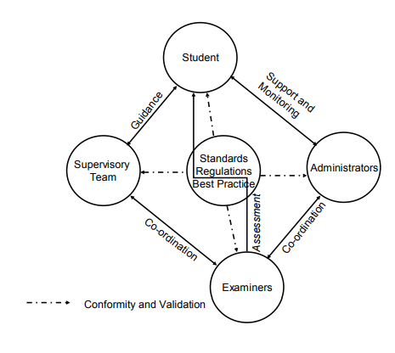

Figure 3.8 Dataflow diagram of the system

3.6 PROGRAM MODULE SPECIFICATION
From implementation standpoint, modules are implemented in this project as application logic in the software application. A module may contain several pages each of which is used to perform a specific function.

3.6.1 OUTPUT/INPUT SPECIFICATION
There are various input and output screens
THE LOGIN PAGE:
Here the administrator, student or lecturer login to their own page.
THE REGISTRATION FOR:
Here the students register for their information and course.
ADMIN DASHBOARD
This is where administrator can manage all the activities on the system.

3.6.2 OUTPUT SCREENS:
1) THE VIEW PROFILE MODULE: - This module should provide a view of the registered user. The login id, user name id, Name, e-mail id, Performance etc.
2) THE EDIT PROFILE MODULE: - The Edit profile module should have fields such as Login id, Password, Confirm Password, User name. One can make changes to the data entered.
THE EDIT PASWORD MODULE: The user can change its password through this module.

3.7 FILE/DATABASE SPECIFICATION
Data supplied by users have to be stored in a database. In this case. Our database software is MS-ACCESS.
Table 1: Information about the database
No. | Field Name | Range of valid values for the field | Remarks
1 | Groupcode | Some auto-generated unique number | This is the key field of the database as it is unique for each an every student group.  The groupcode i.e. unique code for a group along with the student name forms the composite primary key.
2 | Name | Up to 15 characters in length. | Special characters like underscore are not allowed.
3 | Age | This should be less than 25 for any team member
4 | Email Id | Up to 25 characters in length (including the domain name) | This field should also be unique for a person because no two people can have the same email id
5 | Department | Should be less than 200
6 | Lecturer’s name | Up to 15 characters in length.
7 | Lecturer’s email | Up to 25 characters in length (including the domain name) | This field should also be unique for a person because no two people can have the same email id. This forms the primary key for the professor
8 | Admin user and password | These should be hard coded in the database | As the administrator assigns the professors an account initially. He must have direct access to the database.
9

3.8 OVERVIEW OF THE PROPOSED SYSTEMS BLOCK DIAGRAM
The development of any web solution begins by first sketching a rough diagram of your design based on the basic pages that need to be created. The diagram shown below illustrates the structure of the web application. The entire pages do not all inter link because the creation of a new, personalized presentation is available only if no session exist for the current user.
figure 3.9 below show the basic design of the web application:
login
Online registration
Database of students/lecturer information
Student/Group own page (Profile)
View registration details

Figure 3.9: Block Diagram of the Proposed System

CHAPTER FOUR

4.0 IMPLEMENTATION AND TESTING

4.1 INTRODUCTION
This chapter contains the system implementation which is the transformation of the logical system design into codes which include the type of programming language used to make the software. Moreover, it contain the type of technique used to described the software which is Black-box testing. Black-box testing shows the work of the software. i.e to ensure that the software really gave the output that is expected from it.

4.2 SYSTEM IMPLEMENTATION
System implementation refers to the transformation of the logical system design into program codes for the purpose of putting the newly developed system into operation.
The program backend is heavily built using the following
- PHP. PHP (recursive acronym for “PHP: Hypertext Preprocessor”)
- widely-used Open Source general-purpose scripting language especially suited for Web development
- HTML.

4.3 SYSTEM CHANGE OVER
The parallel method is adopted in the changeover process. This method was adopted because it creates an avenue where by the old and new systems are being run concurrently. With this method, the users of the system will gain a practical knowledge of how the new system is being operated. When this is achieved, the old system is discontinued and the new system takes its place. This method also helps to introduce the new system to users having little or no notice of the change over process.

4.4 SYSTEM TESTING
For the implementation of the new system, data must be prepared for live testing. The result from the new system is compared to that of the existing system to check if the expected result was achieved. It is also necessary to formulate the operation of the new system to check the overall time and ability of the staff to handle the operation of the new system.

4.5 SYSTEM REVIEW MAINTENANCE
The system should be reviewed and maintained periodically in order to deal with unforeseen operational problems that may arise and to make sure that the new system meets its planned objectives or standard.

4.6 DOCUMENTATION
The administrator controls the logging in process in such a way that unauthorized user do not log in, add new lecturer/supervisor to the list, update lecturer/supervisor’s profile, determine if a student should be given project supervisor after students assessment, add and delete student or supervisor below requirement.

4.3.1 LOGIN FORM
This is where a user can input his credentials in order to log into his dashboard. A user can select his role in the form i.e. either admin or student and then log into the system.
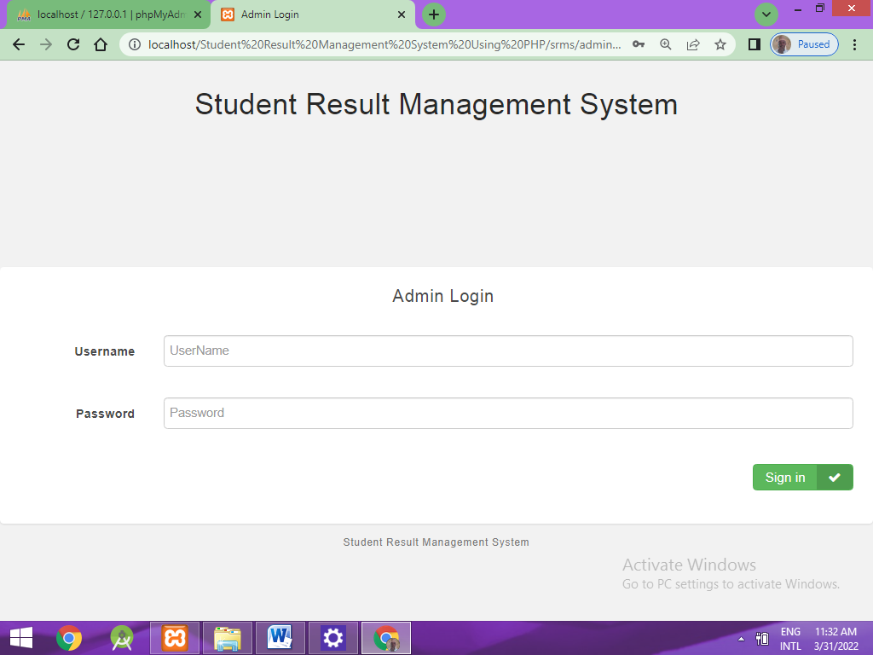

Figure 4.3.2: Admin login form

4.3.2 ADMIN DASHBOARD
This is the dashboard of the admin where he can manage subject, classes, courses, students, scores, and query result report; he can also post notification online.
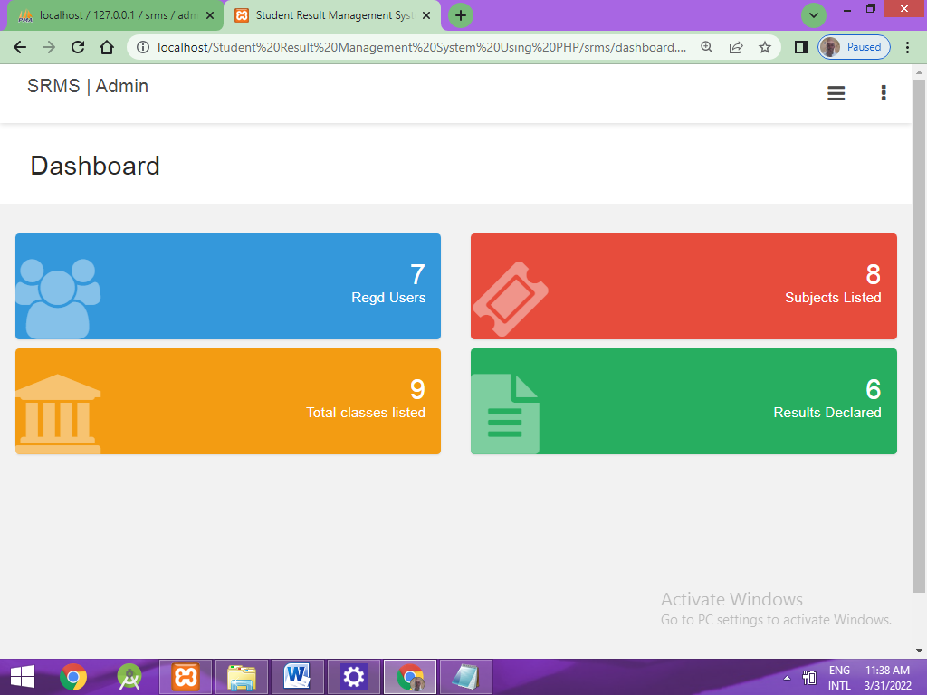

Figure 4.3.3: Admin Dashboard

4.3.3 STUDENT LOGIN FORM
This is the form that is responsible for searching result by a student using his Id_No and. The form is shown in the figure below:
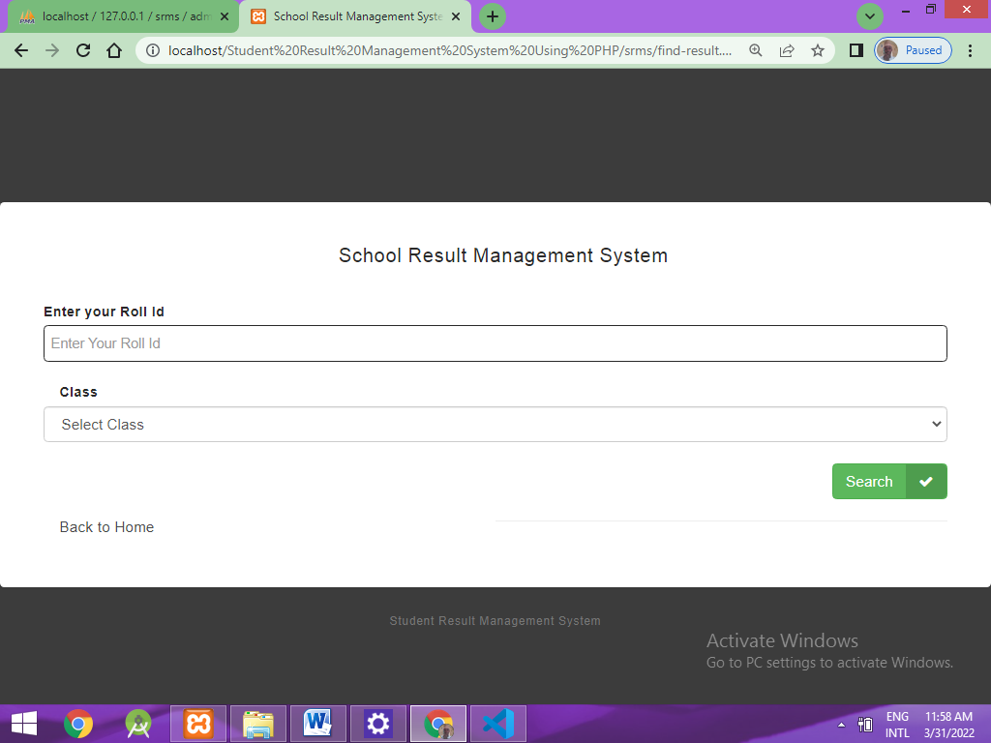

Figure 4.3.4: Student Login form

4.3.4 student result page
This page shows the information of a student as well as the result scored in every courses he registered as shown below.
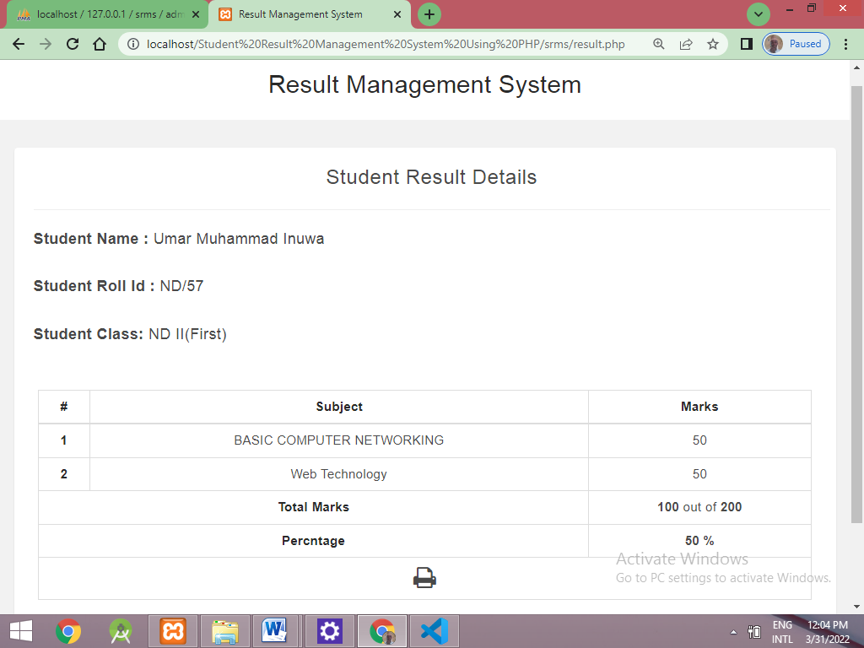

Figure 4.3.5: Result Page

CHAPTER FIVE

SUMMARY, RECOMMENDATION AND CONCLUSION

5.1 SUMMARY
In summary, Performance evaluation of students in institution is a necessity and this is done based on the Grading system adopted by a school. Computation of Grade point average (GPA) is done manually and this is time consuming and tedious.
This project views the present system of computing GPA and attempts to convert the process from manual to a computerized in order to reduce the time spent in computing students GPA especially in the final year.

5.2 CONCLUSION
The Internet has truly changed the way we do a lot of things today; we now have the ability to do virtually everything from our computers. The student performance evaluation system is an emerging technology and a computer system has revolutionized the world thereby making tasks that seems difficult easy by the use of Internet. This project work has emphasized the capabilities and reliabilities of a computer system i.e. It accuracy, speed and timeliness of information that it encompasses.
In addition, we have conducted a usability study via a website by deploying the web application on a domain for only few invited developers to test the application in order to understand usability issues and suggest future improvements.

5.3 RECOMMENDATION
Considering all that has been researched, I would like to emphasize that the adoption of this new System will not be regretted as it would rather be a help for building more complex design to boost operations and promote the cooperate image of our academic institution. I would also advise that this system be employed in other aspect of our educational system to revive the fallen image of our educational system.
Like the saying goes, there is' nothing with advantages without disadvantages; this System may result in overhead in some application but the benefits to be derived overrides the overheads.
The designed System is capable of storing needed information, analyzing them, limiting access to information for integrity purposes, but it is however recommended that the different conditions stipulated for the smooth operations of the application are strictly adhered

REFERENCE
1. Abraham, D.J., Irving, R.W. and Manlove, D.F., The Student-Performance evaluation problem. In: Lecture Notes in Computer Science, vol. 2906. Springer-Verlag. pp. 474-484.
2. Kimani, G. N., Kara, A. M. & Njagi, L. W. (2013). Teachers’ factors influencing students’ academic achievement in secondary schools in Nyandarua County, Kenya. International journal of education and research, 1(3), 1-14. Lee, J.Y. (2013). Private tutoring and its impact on students’ academic achievement, formal schooling, and educational inequality in Korea.
3. Columbia University: Unpublished, PhD thesis. MacNeil, A. & McClanahan, A. (2005). Shared leadership. Retrieved 14May, 2013from:http://conx.org/content/m12923/latest/
4. Matambo, O. K. (2013). 2013 Budget speech. Gaborone: Government Printers Kgosikebatho, K. (2013). Experts pinpoint causes of poor results. Retrieved 19 August, 2013 from: www.thepatriotonsunday.co.bw/experts-pinpoint-causes-of-poor-results.
5. Monyatsi, P.P. (2001). An investigation of the effectiveness of the current teacher appraisal system as practised in Botswana secondary schools.

APPENDIX A
<!DOCTYPE html>
<html lang="en">
<?php session_start() ?>
<?php
if(!isset($_SESSION['login_id']))
header('location:login.php');
include 'db_connect.php';
ob_start();
if(!isset($_SESSION['system'])){

$system = $conn->query("SELECT * FROM system_settings")->fetch_array();
foreach($system as $k => $v){
$_SESSION['system'][$k] = $v;
}
}
ob_end_flush();

include 'header.php'
?>
<body class="hold-transition sidebar-mini layout-fixed layout-navbar-fixed layout-footer-fixed">
<div class="wrapper">
<?php include 'topbar.php' ?>
<?php include $_SESSION['login_view_folder'].'sidebar.php' ?>

<!-- Content Wrapper. Contains page content -->
<div class="content-wrapper">
<div class="toast" id="alert_toast" role="alert" aria-live="assertive" aria-atomic="true">
<div class="toast-body text-white">
</div>
</div>
<div id="toastsContainerTopRight" class="toasts-top-right fixed"></div>
<!-- Content Header (Page header) -->
<div class="content-header">
<div class="container-fluid">
<div class="row mb-2">
<div class="col-sm-6">
<h1 class="m-0"><?php echo $title ?></h1>
</div><!-- /.col -->

</div><!-- /.row -->
<hr class="border-primary">
</div><!-- /.container-fluid -->
</div>
<!-- /.content-header -->

<!-- Main content -->
<section class="content">
<div class="container-fluid">
<?php
$page = isset($_GET['page']) ? $_GET['page'] : 'home';
if(!file_exists($_SESSION['login_view_folder'].$page.".php")){
include '404.html';
}else{
include $_SESSION['login_view_folder'].$page.'.php';

}
?>
</div><!--/. container-fluid -->
</section>
<!-- /.content -->
<div class="modal fade" id="confirm_modal" role='dialog'>
<div class="modal-dialog modal-md" role="document">
<div class="modal-content">
<div class="modal-header">
<h5 class="modal-title">Confirmation</h5>
</div>
<div class="modal-body">/body></html>

APPENDIX B

